Report

모바일 텀프로젝트 최종보고서

|  |  |
| --- | --- |
| 과목 | 모바일 프로그래밍(01) |
| 담당교수 | 공기석 교수님 |
| 팀편성 | 10팀 (3명) |
| 팀원 | 2017156010 김충희 |
| 팀원 | 2013152036 정재훈 |
| 팀원 | 2016152027 오성필 |

**목차**

**1. 개요**

**2. 역할 분담**

**3. 일정**

**4. 프로그램 구성**

**5. 개발 결과 - 실행화면**

**6. 보완해야할 점, 의견**

**7. 참고자료**

**8. 개발 결과 - 소스코드**

**1. 개요**

**2. 역할 분담**

|  |  |
| --- | --- |
| 김충희 | 로그인 화면, 사용자 정보 DB처리, 사이드 메뉴, 정보 변경 기능  최종 보고서 작성 |
| 정재훈 | 날짜 선택, 영화리스트 화면, 좌석 선택 기능, 예매결과 파일처리  프로젝트 제안서 작성, 발표 자료 작성 |
| 오성필 | 자료조사 |

**3. 일정**

|  |  |
| --- | --- |
| **기간** | **내역** |
| 4/29 ~ 5/6 | 안드로이드 앱 기본 목표 설정 및 제안서 작성, 제출 |
| 5/6 ~ 5/13 | 앱 기본 기능 구현: 로그인 화면 및 날짜, 영화 선택 화면 |
| 5/13 ~ 5/20 | 앱 세부 기능 구현: 사이드 메뉴, 정보수정, 좌석 선택, 결제 기능 |
| 5/20 ~ 5/26 | 오류 수정 및 마무리, 발표자료, 최종보고서 작성 |
| 5/27 | 발표 및 소스코드, 최종보고서 제출 |

**4. 프로그램 구성**

|  |  |  |
| --- | --- | --- |
| 액티비티 | 구성 파일 | 기능 |
| 로그인 화면  FirstActivity | MainActivity.java  activity_main.xml  signup.xml  login.xml | 회원가입: 입력한 정보를 SQLite 로 구현한 DB에 입력 |
| 로그인: 입력한 정보와 DB 정보를 비교하여 일치하면 그 정보를 SecondActivity로 전달 |
| 날짜 선택화면  SecondActivity | SecondActivity.java  second_main.xml  menucontent.xml  menuheader.xml  Fragment1.java  Fragment2.java  fragment1.xml  fragment2.xml | 날짜 선택: 캘린더 뷰에서 날짜를 선택하고 FirstActivity에서 가져온 사용자 정보와 함께 ThirdActivity로 전달 |
| 정보 변경: 사용자의 이름과 비밀번호를 변경할 수 있는 EditText창을 제공 |
| 예매 정보 표시: FourthActivity에서 작성한 파일에서 데이터를 읽어와 예매 정보를 표시 |
| 로그아웃: 액티비티를 종료하고 로그인 화면으로 이동 |
| 사이드 메뉴: 로그인 정보를 표시하고, Second액티비티의 다른 기능들로 이동하는 버튼 제공 |
| 영화 리스트  ThirdActivity | MovieList.java  Movielist.xml  Movielist.dialog  strings.xml | 영화 리스트: 영화 리스트를 출력하고 그리드뷰,스크롤바를 사용하여 화면에 표시 |
| 영화 정보 다이얼로그: 선택한 영화의 포스터와 배우, 시놉시스 등의 정보를 다이얼로그로 표현. 예매하기 버튼을 누르면 영화의 정보, 사용자의 정보, 날짜 정보를 FourthActivity로 전달 |
| 영화 트레일러: 클릭 시 선택한 영화의 예고편으로 링크 |
| 좌석 선택  FourthActivity | MovieSit.java  moviesit.xml | 좌석 선택: 좌석을 선택하여 보여줌 |
| 결제: 날짜, 영화, 좌석 정보를 파일에 저장하고 차감된 금액을 DB에서 갱신 |

**5. 개발 결과 – 실행화면**

**5-1. 로그인 화면**

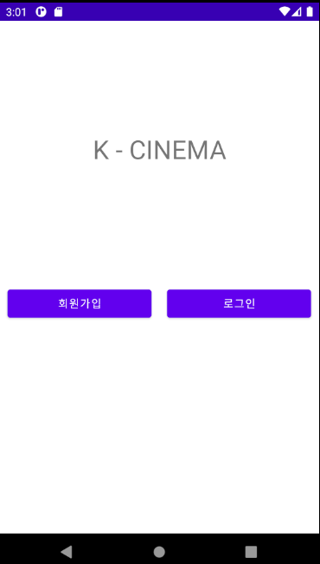

**-** 회원 가입 버튼과 로그인 버튼이 있으며, 버튼을 누르면 각각의 기능을 가진 다이얼로그가 열린다.

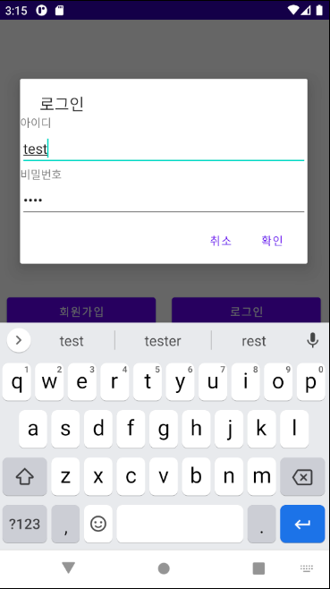

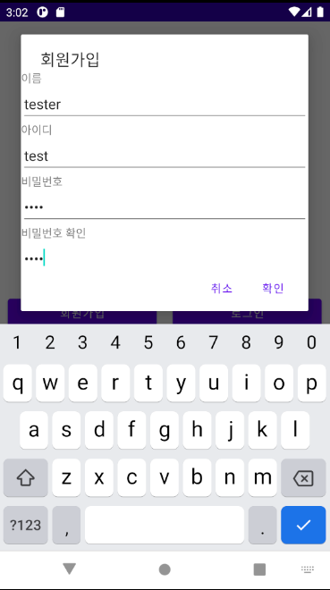

- 이름, 아이디, 비밀번호를 입력하여 회원가입을 할 수 있다.

- 공백 또는 20자 이상은 입력할 수 없으며, 두 비밀번호가 같아야 가입을 완료할 수 있다.

- 아이디와 비밀번호를 입력하여 로그인 할 수 있다. 로그인에 성공하면 날짜 선택 화면으로 넘어간다.

**5-2. 날짜 선택/정보변경**

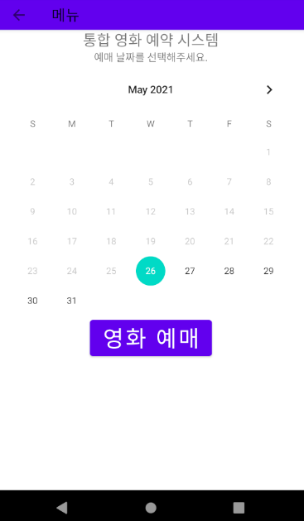

**-** 로그인 성공시 영화 예약 날짜를 선택할 수 있는 창으로 넘어온다

- 영화 예매 버튼을 누르면 영화리스트를 선택할 수 있는 창으로 이동한다.

- 현재 시간부터 6일 후의 날짜까지 예매할 수 있다.

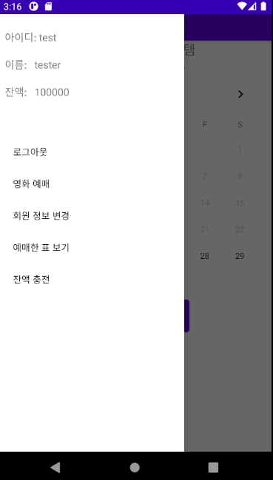

- 좌상단 화살표키를 누르거나 화면을 슬라이드하면 사이드 메뉴가 열린다

- 메뉴 상단에서 로그인 정보를 확인할 수 있다.

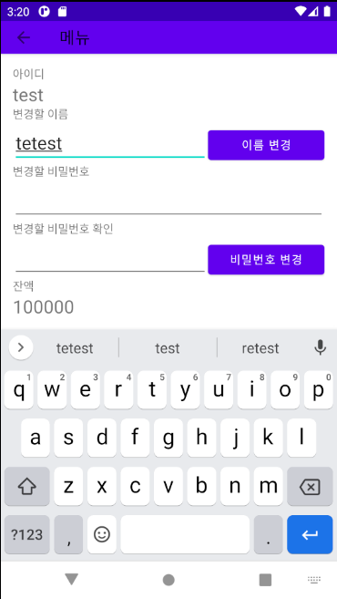

- 정보 변경 화면에서 이름과 비밀번호를 변경할 수 있다.

- 변경된 결과는 사이드 메뉴와 DB에 반영된다.

**5-3. 영화 리스트**

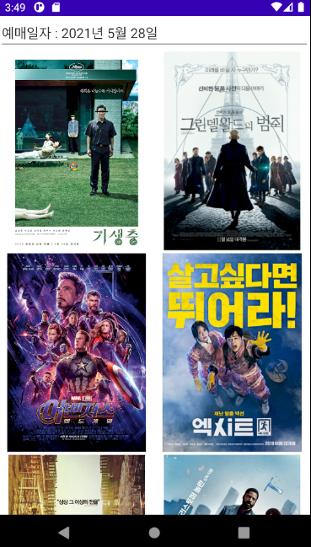

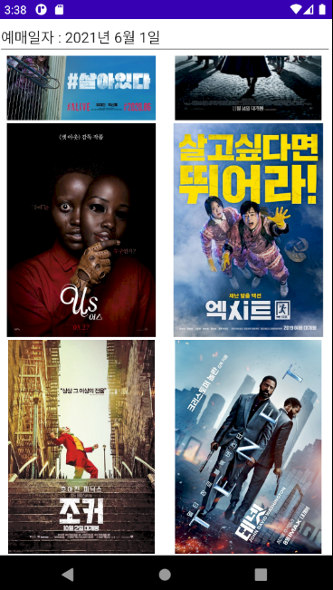

- 날짜를 선택하면 해당하는 날짜의 영화 리스트를 볼 수 있다. 다른 날짜를 선택하면 다른 리스트가 나타난다.

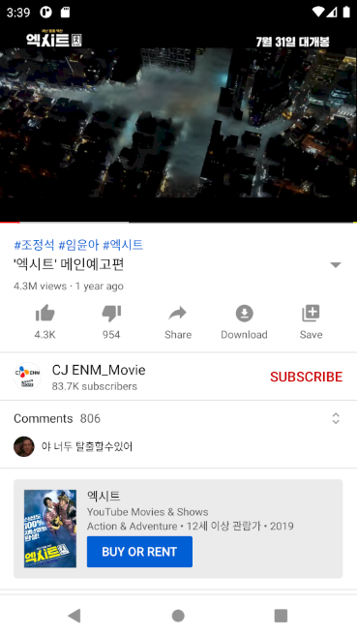

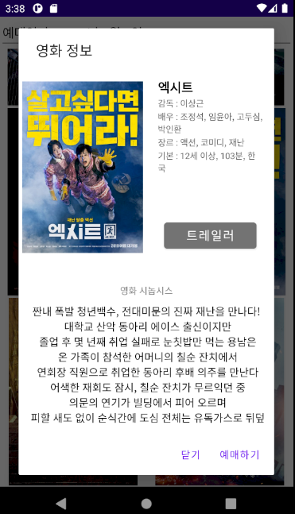

- 영화 이미지를 클릭하면 감독, 배우, 시놉시스 등 해당 영화의 정보를 확인할 수 있다

- ‘트레일러’ 버튼을 누르면 영화의 예고편 유튜브 링크로 연결된다.

**5-4. 좌석 선택**

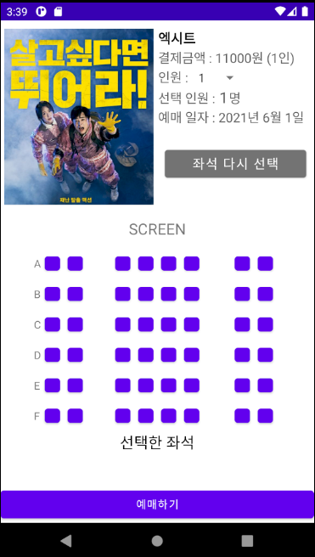

- 좌석 선택 창에서는 1~3명의 좌석을 지정하여 예매를 진행할 수 있고, ‘좌석 다시 선택’ 버튼으로 다시 좌석을 지정할 수 있다.

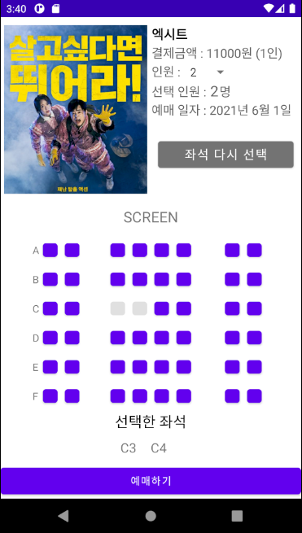

- 2명의 자리를 선택하고 예매를 진행하였다. 보유금액에서 티켓값이 차감되고 예매가 완료되면 SecondActivity의 날짜 선택 화면으로 돌아간다.

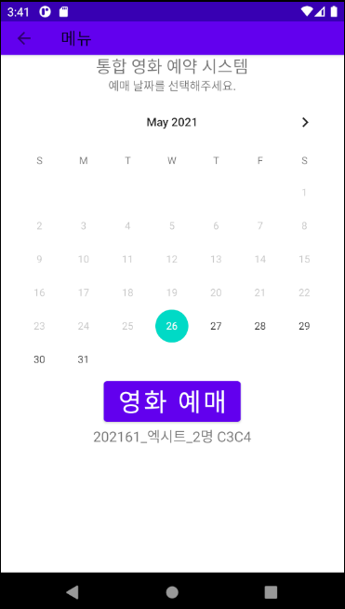

- 사이드 메뉴의 예매 정보 버튼을 클릭하면 예매된 정보를 확인할 수 있다.

**6. 보완해야 할 점, 제약사항**

- 다양한 영화관 및 영화를 예약하는 기능은 그 수에 비례하여 많은 정보를 입력해야 하기 때문에 어려움.

- 예매/좌석선택 액티비티에서 예매정보를 가져와서 영화 포스터, 포토티켓 형식으로 구현

- DB데이터를 조작할 때 DBHelper, SQLiteDB 인스턴스를 계속 생성하여 사용. 코드의 낭비를 줄이기 위해 함수처리 필요

**7. 참고자료**

네비게이션 뷰 (사이드메뉴) 관련 참고자료

[*https://developer.android.com/guide/navigation/navigation-ui?hl=ko*](https://developer.android.com/guide/navigation/navigation-ui?hl=ko)

[*https://lktprogrammer.tistory.com/168*](https://lktprogrammer.tistory.com/168)

SecondActivity 에서 프래그먼트 구현 관련 참고자료

[*https://developer.android.com/guide/components/fragments.html?hl=ko*](https://developer.android.com/guide/components/fragments.html?hl=ko)

**8. 개발 결과 – 소스코드**

길이 문제로 마지막 단원에 위치시켰다.

**8-1. 로그인화면**

**MainActivity.java**

회원가입, 로그인 다이얼로그를 띄우고 사용자가 입력한 정보를 바탕으로 DB에 등록, 조회하는 코드.

package termproject1.myapplication;  
  
import androidx.appcompat.app.AlertDialog;  
import androidx.appcompat.app.AppCompatActivity;  
  
import android.content.ContentValues;  
import android.content.Context;  
import android.content.DialogInterface;  
import android.content.Intent;  
import android.database.Cursor;  
import android.database.sqlite.SQLiteConstraintException;  
import android.database.sqlite.SQLiteDatabase;  
import android.database.sqlite.SQLiteOpenHelper;  
import android.os.Bundle;  
import android.view.View;  
import android.widget.Button;  
import android.widget.EditText;  
import android.widget.Toast;

public class MainActivity extends AppCompatActivity {  
  
 Button btnLogIn, btnSignUp;  
 View dlgSignUp, dlgLogin;  
 DBHelper dbHelper;  
 SQLiteDatabase sqlDB;  
  
 public static class DBHelper extends SQLiteOpenHelper {  
 public DBHelper(Context context) {  
 super(context, "groupDB", null, 1);  
  
 }  
  
 @Override  
 public void onCreate(SQLiteDatabase db) {  
 db.execSQL("CREATE TABLE groupTBL(gName CHAR(20) , gId CHAR(20) PRIMARY KEY, gPw CHAR(20),gCash INTEGER);");  
  
 }  
  
 @Override  
 public void onUpgrade(SQLiteDatabase db, int i, int i1) {*//본래 안드로이드 버전업시 초기화하는 용도이지만 그냥 초기화하는 용도로 사용* db.execSQL("DROP TABLE IF EXISTS groupTBL");  
 onCreate(db);  
 }  
 }  
  
  
 @Override  
 protected void onCreate(Bundle savedInstanceState) {  
 super.onCreate(savedInstanceState);  
 setContentView(R.layout.*activity_main*);  
 setTitle("KPU CINEMA");  
  
 btnLogIn = (Button) findViewById(R.id.*logIn*);  
 btnSignUp = (Button) findViewById(R.id.*signUp*);  
 dbHelper = new DBHelper(this);  
  
  
  
 *//회원가입* btnSignUp.setOnClickListener(new View.OnClickListener() {  
 @Override  
 *//다이얼로그로 정보입력창을 띄움* public void onClick(View view) {  
 dlgSignUp = (View) View.*inflate*(MainActivity.this, R.layout.*signup*, null);  
 AlertDialog.Builder dlgBuilder = new AlertDialog.Builder(MainActivity.this);  
 dlgBuilder.setTitle("회원가입");  
 EditText edtName = (EditText) dlgSignUp.findViewById(R.id.*edtName*);  
 EditText edtId = (EditText) dlgSignUp.findViewById(R.id.*edtId*);  
 EditText edtPw = (EditText) dlgSignUp.findViewById(R.id.*edtPw*);  
 EditText edtPw2 = (EditText) dlgSignUp.findViewById(R.id.*edtPw2*);  
  
 dlgBuilder.setView(dlgSignUp);  
*//getButton에서 오버라이드* dlgBuilder.setPositiveButton("확인", new DialogInterface.OnClickListener() {  
 @Override  
 public void onClick(DialogInterface dialogInterface, int i) {  
 }  
 });  
  
 dlgBuilder.setNegativeButton("취소", null);  
 AlertDialog dialog = dlgBuilder.create();  
 dialog.show();  
 *//회원가입-확인 버튼 클릭* dialog.getButton(AlertDialog.*BUTTON_POSITIVE*).setOnClickListener(new View.OnClickListener() {  
 @Override  
  
 public void onClick(View view) {  
 String inputName=edtName.getText().toString();  
 String inputId=edtId.getText().toString();  
 String inputPw=edtPw.getText().toString();  
 String inputPw2=edtPw2.getText().toString();  
 *//입력란에 공백이 있는 경우* if (inputName.equals("")|| inputId.equals("") || inputPw.equals("")|| inputPw2.equals(""))  
 {  
 Toast.*makeText*(MainActivity.this, "빈칸에 정보를 입력해 주십시오", Toast.*LENGTH_SHORT*).show();  
 }  
 *//두 비밀번호가 다른 경우* else if (!inputPw.equals(inputPw2))  
 {  
 Toast.*makeText*(MainActivity.this, "두 비밀번호가 다릅니다. 다시 입력해 주십시오", Toast.*LENGTH_SHORT*).show();  
 }   
 *//ID, PW,닉네임 길이제한* else if(inputName.length()>20||inputId.length()>20||inputPw.length()>20){  
 Toast.*makeText*(MainActivity.this, "20자를 초과하여 설정할 수 없습니다", Toast.*LENGTH_SHORT*).show();  
 }  
 else  
 {  
 sqlDB = dbHelper.getWritableDatabase();*//* ContentValues cv=new ContentValues();  
 cv.put("gName",inputName);  
 cv.put("gId",inputId);  
 cv.put("gPw",inputPw);  
 cv.put("gCash",100000);  
 *//id중복>SQLiteConstraintException* try {  
 long id=sqlDB.insertOrThrow("groupTBL",null,cv);  
 Toast.*makeText*(MainActivity.this, "회원가입이 완료되었습니다.", Toast.*LENGTH_SHORT*).show();  
 dialog.dismiss();  
 }  
 catch(SQLiteConstraintException e){  
 Toast.*makeText*(MainActivity.this, "이미 존재하는 ID입니다.", Toast.*LENGTH_SHORT*).show();  
 }  
 sqlDB.close();  
 }  
  
 }  
 });  
  
 }  
 });  
  
 *//로그인* btnLogIn.setOnClickListener(new View.OnClickListener() {  
 @Override  
 public void onClick(View view) {  
 dlgLogin = (View) View.*inflate*(MainActivity.this, R.layout.*login*, null);*//로그인창 띄우기* AlertDialog.Builder dlgBuilder = new AlertDialog.Builder(MainActivity.this);  
 dlgBuilder.setTitle("로그인");  
 dlgBuilder.setView(dlgLogin);  
  
 EditText edtId = (EditText) dlgLogin.findViewById(R.id.*edtId*);  
 EditText edtPw = (EditText) dlgLogin.findViewById(R.id.*edtPw*);  
   
 dlgBuilder.setPositiveButton("확인", new DialogInterface.OnClickListener() {*//getButton에서 오버라이드* @Override  
 public void onClick(DialogInterface dialogInterface, int i) {  
 }  
 });  
  
 dlgBuilder.setNegativeButton("취소", null);  
  
 AlertDialog dialog = dlgBuilder.create();  
 dialog.show();  
 dialog.getButton(AlertDialog.*BUTTON_POSITIVE*).setOnClickListener(new View.OnClickListener() {  
 @Override  
 public void onClick(View view) {  
 String inputId=edtId.getText().toString();  
 String inputPw=edtPw.getText().toString();  
 if (inputId.equals("")  
 ||inputPw.equals(""))*//입력란에 공백이 있는 경우* {  
 Toast.*makeText*(MainActivity.this, "빈칸을 입력해 주십시오", Toast.*LENGTH_SHORT*).show();  
 }   
 else*//DB 정보와 입력한 정보 비교* {  
  
 sqlDB = dbHelper.getReadableDatabase();  
 Cursor cursor = sqlDB.rawQuery("SELECT * FROM groupTBL WHERE gId='"+inputId+"';", null);*//DB에서 검색 후 데이터* cursor.moveToFirst();  
 if(!cursor.isFirst()){*//id를 조회할 수 없을 때* Toast.*makeText*(MainActivity.this, "잘못된 아이디 또는 비밀번호 입니다.\n다시 입력해 주십시오", Toast.*LENGTH_SHORT*).show();  
 }  
 else {  
  
 if (cursor.getString(2).equals(inputPw)) {

*//로그인 성공, second액티비티로 전환* Toast.*makeText*(MainActivity.this, "로그인 성공", Toast.*LENGTH_SHORT*).show();  
  
 Intent intent =new Intent(MainActivity.this, SecondActivity.class);  
 intent.putExtra("gname",cursor.getString(0));*//닉네임* intent.putExtra("gid",cursor.getString(1));*//ID* intent.putExtra("gpw",cursor.getString(2));*//Pw* intent.putExtra("gcash",cursor.getInt(3));*//돈* cursor.close();  
 sqlDB.close();  
 dialog.dismiss();  
 startActivity(intent);  
 finish();  
 } else {*//비밀번호 틀렸을 때* cursor.close();  
 sqlDB.close();  
 Toast.*makeText*(MainActivity.this, "잘못된 아이디 또는 비밀번호 입니다.\n다시 입력해 주십시오", Toast.*LENGTH_SHORT*).show();  
 }  
 }  
  
 }  
 }  
 });  
 }  
 });  
 }  
}

**activity_main.xml**

로그인 화면을 구성하는 코드

*<?*xml version="1.0" encoding="utf-8"*?>*<LinearLayout xmlns:android="http://schemas.android.com/apk/res/android"  
 xmlns:app="http://schemas.android.com/apk/res-auto"  
 xmlns:tools="http://schemas.android.com/tools"  
 android:layout_width="match_parent"  
 android:layout_height="match_parent"  
 android:orientation="vertical"  
 tools:context=".MainActivity">  
  
 <LinearLayout  
 android:layout_width="match_parent"  
 android:layout_height="match_parent"  
 android:layout_gravity="top"  
 android:layout_weight="1">  
 <TextView  
 android:layout_width="match_parent"  
 android:layout_height="wrap_content"  
 android:textSize="15pt"  
 android:textAlignment="center"  
 android:layout_gravity="center"  
 android:text="K - CINEMA"/>  
 </LinearLayout>  
 <LinearLayout  
 android:layout_width="match_parent"  
 android:layout_height="match_parent"  
 android:layout_weight="1"  
 android:layout_gravity="top"  
 android:orientation="horizontal">  
  
  
 <Button  
 android:layout_width="match_parent"  
 android:layout_height="wrap_content"  
 android:layout_weight="1"  
 android:text="회원가입"  
 android:layout_margin="10dp"  
 android:id="@+id/signUp"/>  
 <Button  
 android:layout_width="match_parent"  
 android:layout_height="wrap_content"  
 android:layout_weight="1"  
 android:text="로그인"  
 android:layout_margin="10dp"  
 android:id="@+id/logIn"/>  
 </LinearLayout>  
</LinearLayout>

**signup.xml**

회원가입 다이얼로그 화면을 구성하는 코드

*<?*xml version="1.0" encoding="utf-8"*?>*<LinearLayout xmlns:android="http://schemas.android.com/apk/res/android"  
 android:orientation="vertical" android:layout_width="match_parent"  
 android:layout_height="match_parent">  
 <ScrollView  
 android:id="@+id/scrollView"  
 android:layout_width="match_parent"  
 android:layout_height="match_parent">  
 <LinearLayout  
 android:layout_width="match_parent"  
 android:layout_height="match_parent"  
 android:orientation="vertical">  
 <TextView  
 android:layout_width="match_parent"  
 android:layout_height="wrap_content"  
 android:text="이름"/>  
 <EditText  
 android:layout_width="match_parent"  
 android:layout_height="wrap_content"  
 android:id="@+id/edtName"/>  
 <TextView  
 android:layout_width="match_parent"  
 android:layout_height="wrap_content"  
 android:text="아이디"/>  
 <EditText  
 android:layout_width="match_parent"  
 android:layout_height="wrap_content"  
 android:id="@+id/edtId"/>  
 <TextView  
 android:layout_width="match_parent"  
 android:layout_height="wrap_content"  
 android:text="비밀번호"/>  
 <EditText  
 android:layout_width="match_parent"  
 android:layout_height="wrap_content"  
 android:inputType="textPassword"  
 android:id="@+id/edtPw"/>  
 <TextView  
 android:layout_width="match_parent"  
 android:layout_height="wrap_content"  
 android:text="비밀번호 확인"/>  
 <EditText  
 android:layout_width="match_parent"  
 android:layout_height="wrap_content"  
 android:inputType="textPassword"  
 android:id="@+id/edtPw2"/>  
 </LinearLayout>  
 </ScrollView>  
  
</LinearLayout>

**login.xml**

로그인 다이얼로그 화면을 구성하는 코드

*<?*xml version="1.0" encoding="utf-8"*?>*<LinearLayout xmlns:android="http://schemas.android.com/apk/res/android"  
 android:orientation="vertical" android:layout_width="match_parent"  
 android:layout_height="match_parent">  
  
 <TextView  
 android:layout_width="match_parent"  
 android:layout_height="wrap_content"  
 android:text="아이디"/>  
 <EditText  
 android:layout_width="match_parent"  
 android:layout_height="wrap_content"  
 android:id="@+id/edtId"/>  
 <TextView  
 android:layout_width="match_parent"  
 android:layout_height="wrap_content"  
 android:text="비밀번호"/>  
 <EditText  
 android:layout_width="match_parent"  
 android:layout_height="wrap_content"  
 android:inputType="textPassword"  
 android:id="@+id/edtPw"/>  
  
  
</LinearLayout>

**8-2. 날짜 선택 화면**

**SecondActivity.java**

Fragment1, 2 를 생성. 네비게이션 메뉴 구현, 메뉴 항목 클릭시 화면 전환을 처리하는 코드. 기본으로 보여지는 화면은 Fragment1

package termproject1.myapplication;  
  
import androidx.annotation.NonNull;  
import androidx.appcompat.app.ActionBarDrawerToggle;  
import androidx.appcompat.app.AppCompatActivity;  
import androidx.appcompat.widget.Toolbar;  
import androidx.core.view.GravityCompat;  
import androidx.drawerlayout.widget.DrawerLayout;  
import androidx.fragment.app.Fragment;  
import androidx.fragment.app.FragmentHostCallback;  
import androidx.fragment.app.FragmentManager;  
import androidx.fragment.app.FragmentTransaction;  
  
import android.app.ActionBar;  
import android.content.Intent;  
import android.database.Cursor;  
import android.database.sqlite.SQLiteDatabase;  
import android.graphics.Color;  
import android.os.Bundle;  
import android.os.Handler;  
import android.view.MenuItem;  
import android.view.View;  
import android.widget.Button;  
import android.widget.CalendarView;  
import android.widget.TextView;  
import android.widget.Toast;  
  
import com.google.android.material.navigation.NavigationView;  
  
import java.io.FileInputStream;  
import java.io.IOException;  
import java.text.ParseException;  
import java.text.SimpleDateFormat;  
import java.util.Date;  
  
public class SecondActivity extends AppCompatActivity {  
  
 Toolbar toolbar;  
 Fragment fr1, fr2, fr3;  
  
 String id;  
 String name;  
 String pw;  
 int cash;  
 SQLiteDatabase sqlDB;  
 MainActivity.DBHelper dbHelper;  
 TextView menuname,menuid,menucash;  
  
  
 String fName = null;  
 @Override  
 protected void onCreate(Bundle savedInstanceState) {  
 super.onCreate(savedInstanceState);  
 setContentView(R.layout.*second_main*);  
 *//네비게이션 관련 https://developer.android.com/guide/navigation/navigation-ui?hl=ko 참조  
 //프래그먼트 관련 https://developer.android.com/guide/components/fragments.html?hl=ko* DrawerLayout drawerLayout = (DrawerLayout) findViewById(R.id.*seconddrawer*);  
 NavigationView navigationView = (NavigationView) findViewById(R.id.*secondnavi*);  
 *//앱 상단 앱바* toolbar = (Toolbar) findViewById(R.id.*toolbar*);  
 setSupportActionBar(toolbar);  
 *//toolbar.setVisibility(View.INVISIBLE);  
 //앱바에 메뉴* getSupportActionBar().setDisplayHomeAsUpEnabled(true);  
 *//프래그먼트 관리를 위한 변수* FragmentManager fm = getSupportFragmentManager();  
 FragmentTransaction ft = fm.beginTransaction();  
 fr1 = new Fragment1();  
 fr2 = new Fragment2();  
  
 *//로그인 화면으로부터 전달받는 정보* Intent intent = getIntent();  
 id=intent.getStringExtra("gid");  
 name=intent.getStringExtra("gname");  
 pw=intent.getStringExtra("gpw");  
 cash=intent.getIntExtra("gcash",1);  
  
 *//예매 화면에서 전달받는 정보* String filename = intent.getStringExtra("fName");  
 fName = filename;  
 *//Frag1로 전달할 정보* Bundle bundleToFrag1=new Bundle();  
 bundleToFrag1.putInt("cash",cash);  
 bundleToFrag1.putString("id",id);  
 bundleToFrag1.putString("name",name);  
 fr1.setArguments(bundleToFrag1);  
  
 *//Frag2로 전달할 정보* Bundle bundleToFrag2 = new Bundle();  
 bundleToFrag2.putString("id",id);  
 bundleToFrag2.putInt("cash",cash);  
 fr2.setArguments(bundleToFrag2);  
 ft.add(R.id.*framelayout*, fr1);  
 ft.commit();  
  
  
  
 ActionBarDrawerToggle actionBarDrawerToggle = new ActionBarDrawerToggle(  
 this,  
 drawerLayout,  
 toolbar,  
 R.string.*open*, R.string.*close* )  
 *//메뉴 오픈할 때 사용자 정보 갱신* {  
 @Override  
 public void onDrawerOpened(View drawerView) {  
 super.onDrawerOpened(drawerView);  
 dbHelper=new MainActivity.DBHelper(getApplicationContext());  
 sqlDB = dbHelper.getReadableDatabase();  
  
 menuid=(TextView) findViewById(R.id.*menuid*);  
 menuname=(TextView) findViewById(R.id.*menuname*);  
 menucash=(TextView) findViewById(R.id.*menucash*);  
  
 Cursor cursor = sqlDB.rawQuery("SELECT * FROM groupTBL WHERE gId = '"+id+"';", null);  
 while(cursor.moveToNext()){  
 name = cursor.getString(0);  
 pw = cursor.getString(2);  
 cash = cursor.getInt(3);  
 }  
  
 menuname.setText("이름: "+name);  
 menuid.setText("아이디: "+id);  
 menucash.setText("잔액: "+String.*valueOf*(cash));  
 cursor.close();  
 sqlDB.close();  
 }  
  
 };  
  
  
 drawerLayout.addDrawerListener(actionBarDrawerToggle);  
 navigationView.setNavigationItemSelectedListener(new NavigationView.OnNavigationItemSelectedListener() {  
 @Override  
 public boolean onNavigationItemSelected(@NonNull MenuItem item) {  
 Fragment fr;  
 FragmentManager fm = getSupportFragmentManager();  
 FragmentTransaction ft = fm.beginTransaction();  
 switch (item.getItemId()) {  
 case R.id.*menuitem1*:  
 Intent intent = new Intent(SecondActivity.this, MainActivity.class);  
 startActivity(intent);  
 finish();  
 Toast.*makeText*(getApplicationContext(), "로그아웃 되었습니다", Toast.*LENGTH_SHORT*).show();  
 break;  
 case R.id.*menuitem2*:  
 ft.replace(R.id.*framelayout*, fr1).commit();  
 break;  
 case R.id.*menuitem3*:  
 ft.replace(R.id.*framelayout*, fr2).commit();  
 break;  
 case R.id.*menuitem4*:  
 String list = null;  
 FileInputStream inFs;  
 try {  
 inFs = openFileInput(filename);  
 byte[] txt = new byte[500];  
 inFs.read(txt);  
 inFs.close();  
 list = (new String(txt)).trim();  
 TextView text= (TextView)findViewById(R.id.*textTicket*);  
 text.setText(list);  
 } catch (IOException e) {  
 Toast.*makeText*(getApplicationContext(), "예매 내역이 없습니다.", Toast.*LENGTH_SHORT*).show();  
 }  
 catch (NullPointerException e)  
 {  
 Toast.*makeText*(getApplicationContext(), "예매 내역이 없습니다.", Toast.*LENGTH_SHORT*).show();  
 }  
 break;  
  
 case R.id.*menuitem5*:  
 cash+=50000;  
 bundleToFrag1.putInt("cash",cash);  
 fr1.setArguments(bundleToFrag1);  
 break;  
  
 }  
 DrawerLayout drawer = findViewById(R.id.*seconddrawer*);  
 drawer.closeDrawer(GravityCompat.*START*);  
 return true;  
 }  
  
 });  
 }  
}

**second_main.xml**

SecondActivity 화면을 구성하는 코드.

*<?*xml version="1.0" encoding="utf-8"*?>*<androidx.drawerlayout.widget.DrawerLayout  
 xmlns:android="http://schemas.android.com/apk/res/android"  
 xmlns:tools="http://schemas.android.com/tools"  
 xmlns:app="http://schemas.android.com/apk/res-auto"  
 android:id="@+id/seconddrawer"  
 android:layout_width="match_parent"  
 android:layout_height="match_parent"  
 android:fitsSystemWindows="true"  
 tools:openDrawer="start">  
 <androidx.coordinatorlayout.widget.CoordinatorLayout  
 android:layout_width="match_parent"  
 android:layout_height="match_parent"  
 xmlns:android="http://schemas.android.com/apk/res/android"  
 xmlns:tools="http://schemas.android.com/tools"  
 >  
 <LinearLayout android:orientation="vertical"  
 android:layout_width="match_parent"  
 android:layout_height="match_parent"  
 >  
 <com.google.android.material.appbar.AppBarLayout  
 android:layout_width="match_parent"  
 android:layout_height="wrap_content">  
 <androidx.appcompat.widget.Toolbar  
 android:id="@+id/toolbar"  
 android:layout_width="match_parent"  
 android:layout_height="40dp">  
  
 </androidx.appcompat.widget.Toolbar>  
 </com.google.android.material.appbar.AppBarLayout>  
 <FrameLayout  
 android:layout_width="match_parent"  
 android:layout_height="match_parent"  
 android:id="@+id/framelayout"  
 >  
 </FrameLayout>  
  
  
 </LinearLayout>  
 </androidx.coordinatorlayout.widget.CoordinatorLayout>  
  
 <com.google.android.material.navigation.NavigationView  
 android:layout_width="wrap_content"  
 android:layout_height="match_parent"  
 android:id="@+id/secondnavi"  
 android:layout_gravity="start"  
 android:fitsSystemWindows="true"  
 app:menu="@layout/menucontent"  
 app:headerLayout="@layout/menuheader">  
  
  
  
 </com.google.android.material.navigation.NavigationView>  
  
  
  
</androidx.drawerlayout.widget.DrawerLayout>

**menuheader.xml**

메뉴 상단 화면을 구성하는 코드

*<?*xml version="1.0" encoding="utf-8"*?>*<LinearLayout xmlns:android="http://schemas.android.com/apk/res/android"  
 xmlns:app="http://schemas.android.com/apk/res-auto"  
 android:layout_width="match_parent"  
 android:layout_height="200dp"  
 android:layout_weight="3"  
 android:gravity="center_vertical"  
 android:orientation="vertical">  
 <TextView  
 android:id="@+id/menuid"  
 android:layout_width="match_parent"  
 android:layout_height="wrap_content"  
 android:text="ID"  
 android:layout_margin="10dp"  
 android:layout_marginTop="20dp"  
 android:textSize="7pt"  
 />  
 <TextView  
 android:id="@+id/menuname"  
 android:layout_width="match_parent"  
 android:layout_height="wrap_content"  
 android:text="NAME"  
 android:textSize="7pt"  
 android:layout_margin="10dp"  
 />  
 <TextView  
 android:id="@+id/menucash"  
 android:layout_width="match_parent"  
 android:layout_height="wrap_content"  
 android:text="CASH"  
 android:textSize="7pt"  
 android:layout_margin="10dp"  
 />  
  
</LinearLayout>

**menucontent.xml**

메뉴 하단의 메뉴버튼을 구성하는 코드

*<?*xml version="1.0" encoding="utf-8"*?>*<menu xmlns:android="http://schemas.android.com/apk/res/android" android:layout_height="match_parent"  
 android:layout_width="match_parent">  
 <item  
 android:id="@+id/menuitem1"  
 android:title="로그아웃"/>  
 <item  
 android:id="@+id/menuitem2"  
 android:title="영화 예매"/>  
 <item  
 android:id="@+id/menuitem3"  
 android:title="회원 정보 변경"/>  
 <item  
 android:id="@+id/menuitem4"  
 android:title="예매한 표 보기"/>  
 <item  
 android:id="@+id/menuitem5"  
 android:title="잔액 충전"/>  
  
</menu>

**Fragment1.java**

캘린더뷰에서 날짜를 선택하고, 선택한 날짜의 정보를 MovieList.java로 전달하는 코드

package termproject1.myapplication;  
  
import android.content.Intent;  
import android.os.Bundle;  
import android.view.LayoutInflater;  
import android.view.View;  
import android.view.ViewGroup;  
import android.widget.Button;  
import android.widget.CalendarView;  
import android.widget.ImageView;  
import android.widget.TextView;  
import android.widget.Toast;  
  
import androidx.annotation.NonNull;  
import androidx.annotation.Nullable;  
import androidx.fragment.app.Fragment;  
  
import java.text.ParseException;  
import java.text.SimpleDateFormat;  
import java.util.Date;  
  
public class Fragment1 extends Fragment{  
 Button btnmovie;  
 CalendarView calview1;  
 int selectYear, selectMonth, selectDay;  
 @Override  
 public View onCreateView(@NonNull LayoutInflater inflater, @Nullable ViewGroup container, @Nullable Bundle savedInstanceState) {  
 View view1 = inflater.inflate(R.layout.*fragment1*,container,false);  
 btnmovie = (Button)view1.findViewById(R.id.*BtnMovie*);  
 calview1 = (CalendarView)view1.findViewById(R.id.*CalView*);  
 btnmovie.setOnClickListener(new View.OnClickListener() {  
 @Override  
 public void onClick(View view) {  
 if(!calview1.isSelected())  
 {  
 Toast.*makeText*(getActivity(),"날짜를 선택하십시오",Toast.*LENGTH_SHORT*).show();  
 }  
 else if(DayCount()>6) {  
 Toast.*makeText*(getActivity(),"선택한 날짜에 상영되는 영화가 없습니다.",Toast.*LENGTH_SHORT*).show();  
 }  
 else {  
 int hCash=getArguments().getInt("cash",1);  
 String id=getArguments().getString("id");  
 String lastname=getArguments().getString("name");;  
 Intent intent = new Intent(getActivity(), MovieList.class);  
 intent.putExtra("SelectYear", selectYear);  
 intent.putExtra("SelectMonth", selectMonth);  
 intent.putExtra("SelectDay", selectDay); *// 예매날짜 전달* intent.putExtra("Index",DayCount()); *// 날짜별로 지정* intent.putExtra("id",id);  
 intent.putExtra("mvNick",lastname);  
 intent.putExtra("Cash",hCash); *//잔액 전달* startActivity(intent);  
 getActivity().finish();  
  
 }  
 }  
 });  
  
 calview1.setMinDate(System.*currentTimeMillis*()); *// 과거날짜 선택 불가* calview1.setOnDateChangeListener(new CalendarView.OnDateChangeListener() {  
 @Override  
 public void onSelectedDayChange(@NonNull CalendarView calendarView, int year, int month, int dayOfMonth) {  
 selectYear=year;  
 selectMonth=month+1;  
 selectDay=dayOfMonth;  
 calendarView.setSelected(true);  
 }  
 });  
 return view1;  
 }  
  
 public int DayCount () {  
  
 try {  
 SimpleDateFormat simple = new SimpleDateFormat("yyyy-MM-dd");  
 String current = simple.format(System.*currentTimeMillis*()); *// 현재 날짜 가져오기* String select = selectYear + "-" + selectMonth + "-" + selectDay;  
 Date currentDate = simple.parse(current);  
 Date selectDate = simple.parse(select);  
  
 long gettime = selectDate.getTime() - currentDate.getTime(); *// 선택한 날짜와 일 수 비교* long result = gettime / 86400000;  
 return (int)result;  
 } catch (ParseException e) {  
 e.printStackTrace();  
 return -1;  
 }  
 }  
}

**fragment1.xml**

Fragment1.java의 화면을 구성하는 코드

*<?*xml version="1.0" encoding="utf-8"*?>*<LinearLayout xmlns:android="http://schemas.android.com/apk/res/android"  
 android:orientation="vertical" android:layout_width="match_parent"  
 android:layout_height="match_parent">  
 <LinearLayout  
 android:layout_width="match_parent"  
 android:layout_height="match_parent"  
 android:orientation="vertical">  
  
 <TextView  
 android:layout_width="match_parent"  
 android:layout_height="wrap_content"  
 android:text="통합 영화 예약 시스템"  
 android:gravity="center"  
 android:textSize="20dp"></TextView>  
  
 <TextView  
 android:layout_width="match_parent"  
 android:layout_height="wrap_content"  
 android:text="예매 날짜를 선택해주세요."  
 android:gravity="center"></TextView>  
  
 <CalendarView  
 android:layout_width="match_parent"  
 android:layout_height="wrap_content"  
 android:id="@+id/CalView"></CalendarView>  
  
 <Button  
 android:layout_width="wrap_content"  
 android:layout_height="wrap_content"  
 android:layout_gravity="center"  
 android:id="@+id/BtnMovie"  
 android:text="영화 예매"  
 android:textSize="30dp"></Button>  
  
 <TextView  
 android:layout_width="wrap_content"  
 android:layout_height="wrap_content"  
 android:id="@+id/textTicket"  
 android:layout_gravity="center"  
 android:textSize="17dp"></TextView>  
  
 </LinearLayout>  
</LinearLayout>

**Fragment2.java**

새로운 이름과 비밀번호를 입력받아 DB에서 업데이트 하는 코드

package termproject1.myapplication;  
  
import android.database.sqlite.SQLiteConstraintException;  
import android.database.sqlite.SQLiteDatabase;  
import android.os.Bundle;  
import android.view.LayoutInflater;  
import android.view.View;  
import android.view.ViewGroup;  
import android.widget.Button;  
import android.widget.EditText;  
import android.widget.TextView;  
import android.widget.Toast;  
  
import androidx.annotation.NonNull;  
import androidx.annotation.Nullable;  
import androidx.fragment.app.Fragment;  
  
public class Fragment2 extends Fragment {  
 Button btnChangeName,btnChangePw;  
 TextView edtId, edtCash;  
 EditText edtName,edtPw,edtPw2;  
 MainActivity.DBHelper dbHelper;  
 SQLiteDatabase sqlDB;  
 @Override  
 public View onCreateView(@NonNull LayoutInflater inflater, @Nullable ViewGroup container, @Nullable Bundle savedInstanceState) {  
 View view2 = inflater.inflate(R.layout.*fragment2*,container,false);  
 edtId = (TextView) view2.findViewById(R.id.*edtId*);  
 edtName= (EditText)view2.findViewById(R.id.*edtName*);  
 edtPw = (EditText)view2.findViewById(R.id.*edtPw*);  
 edtPw2 = (EditText)view2.findViewById(R.id.*edtPw2*);  
 btnChangeName = (Button)view2.findViewById(R.id.*btnChangeName*);  
 btnChangePw = (Button)view2.findViewById(R.id.*btnChangePw*);  
 edtCash = (TextView) view2.findViewById(R.id.*edtCash*);  
  
 edtId.setText(getArguments().getString("id"));  
 edtCash.setText(String.*valueOf*(getArguments().getInt("cash",0)));  
 dbHelper = new MainActivity.DBHelper(getActivity());  
  
 btnChangeName.setOnClickListener(new View.OnClickListener() {  
 @Override  
 public void onClick(View view) {  
 String inputName=edtName.getText().toString();  
 String inputId=getArguments().getString("id");  
  
 if (inputName.equals(""))  
 {  
 Toast.*makeText*(getActivity(), "빈칸에 정보를 입력해 주십시오", Toast.*LENGTH_SHORT*).show();  
 }  
 else if(inputName.length()>20) {  
 Toast.*makeText*(getActivity(), "20자를 초과하여 설정할 수 없습니다", Toast.*LENGTH_SHORT*).show();  
 }  
 else {  
 try {  
 sqlDB = dbHelper.getWritableDatabase();  
 String query = ("UPDATE groupTBL SET gName = '"+inputName+"'WHERE gid ='"+inputId+"';");  
 sqlDB.execSQL(query);  
 Toast.*makeText*(getActivity(), "이름 변경 성공!", Toast.*LENGTH_SHORT*).show();  
 } catch (SQLiteConstraintException e) {  
 Toast.*makeText*(getActivity(), "변경에 실패했습니다 다시 시도해주십시오", Toast.*LENGTH_SHORT*).show();  
 }  
  
 sqlDB.close();  
 }  
  
 }  
 });  
 btnChangePw.setOnClickListener(new View.OnClickListener() {  
 @Override  
 public void onClick(View view) {  
 String inputId=getArguments().getString("id");  
 String inputPw=edtPw.getText().toString();  
 String inputPw2=edtPw2.getText().toString();  
 *//빈칸이 있을 경우* if (inputPw.equals("")|| inputPw2.equals(""))  
 {  
 Toast.*makeText*(getActivity(), "빈칸에 정보를 입력해 주십시오", Toast.*LENGTH_SHORT*).show();  
 }  
 *//두 비밀번호가 다른 경우* else if (!inputPw.equals(inputPw2))  
 {  
 Toast.*makeText*(getActivity(), "두 비밀번호가 다릅니다. 다시 입력해 주십시오", Toast.*LENGTH_SHORT*).show();  
 }  
 *//비밀번호 길이제한* else if(inputPw.length()>20){  
 Toast.*makeText*(getActivity(), "20자를 초과하여 설정할 수 없습니다", Toast.*LENGTH_SHORT*).show();  
 }  
 else{  
 try {  
 sqlDB = dbHelper.getWritableDatabase();  
 String query = ("UPDATE groupTBL SET gPw = '"+inputPw+"'WHERE gid ='"+inputId+"'");  
 sqlDB.execSQL(query);  
 Toast.*makeText*(getActivity(), "비밀번호 변경 성공!", Toast.*LENGTH_SHORT*).show();  
 } catch (SQLiteConstraintException e) {  
 Toast.*makeText*(getActivity(), "변경에 실패했습니다 다시 시도해주십시오", Toast.*LENGTH_SHORT*).show();  
 }  
 sqlDB.close();  
  
 }  
 }  
 });  
 return view2;  
 }  
}

**fragment2.xml**

Fragment2의 화면을 구성하는 코드

*<?*xml version="1.0" encoding="utf-8"*?>*<LinearLayout xmlns:android="http://schemas.android.com/apk/res/android"  
 android:orientation="vertical" android:layout_width="match_parent"  
 android:layout_margin="15dp"  
 android:layout_height="match_parent">  
 <TextView  
 android:layout_width="match_parent"  
 android:layout_height="wrap_content"  
 android:text="아이디"/>  
 <TextView  
 android:layout_width="match_parent"  
 android:layout_height="wrap_content"  
 android:textSize="10pt"  
 android:id="@+id/edtId"/>  
 <TextView  
 android:layout_width="match_parent"  
 android:layout_height="wrap_content"  
 android:text="변경할 이름"/>  
 <LinearLayout  
 android:orientation="horizontal"  
 android:layout_width="match_parent"  
 android:layout_height="wrap_content">  
 <EditText  
 android:layout_width="match_parent"  
 android:layout_height="wrap_content"  
 android:layout_weight="3"  
 android:textSize="10pt"  
 android:id="@+id/edtName"/>  
 <Button  
 android:layout_width="match_parent"  
 android:layout_height="wrap_content"  
 android:layout_weight="5"  
 android:id="@+id/btnChangeName"  
 android:text="이름 변경"></Button>  
 </LinearLayout>  
  
 <TextView  
 android:layout_width="match_parent"  
 android:layout_height="wrap_content"  
 android:text="변경할 비밀번호"/>  
 <EditText  
 android:layout_width="match_parent"  
 android:layout_height="wrap_content"  
 android:inputType="textPassword"  
 android:textSize="10pt"  
 android:id="@+id/edtPw"/>  
 <TextView  
 android:layout_width="match_parent"  
 android:layout_height="wrap_content"  
 android:text="변경할 비밀번호 확인"/>  
 <LinearLayout  
 android:orientation="horizontal"  
 android:layout_width="match_parent"  
 android:layout_height="wrap_content">  
 <EditText  
 android:layout_width="match_parent"  
 android:layout_height="wrap_content"  
 android:inputType="textPassword"  
 android:layout_weight="3"  
 android:textSize="10pt"  
 android:id="@+id/edtPw2"/>  
 <Button  
 android:layout_width="match_parent"  
 android:layout_height="wrap_content"  
 android:layout_weight="5"  
 android:id="@+id/btnChangePw"  
 android:text="비밀번호 변경"></Button>  
 </LinearLayout>  
 <TextView  
 android:layout_width="match_parent"  
 android:layout_height="wrap_content"  
 android:text="잔액"/>  
 <TextView  
 android:layout_width="match_parent"  
 android:layout_height="wrap_content"  
 android:id="@+id/edtCash"  
 android:textSize="10pt"/>  
  
  
  
  
</LinearLayout>

**8-3. 영화 선택 화면**

**MovieList.java**

영화 리스트 화면을 그리드뷰로 구성하고 이미지를 클릭 했을 때 영화 정보를 다이얼로그로 띄움.

package termproject1.myapplication;  
  
import android.app.Activity;  
import android.app.AlertDialog;  
import android.app.AppComponentFactory;  
import android.content.Context;  
import android.content.DialogInterface;  
import android.content.Intent;  
import android.net.Uri;  
import android.os.Bundle;  
import android.text.method.ScrollingMovementMethod;  
import android.view.View;  
import android.view.ViewGroup;  
import android.widget.BaseAdapter;  
import android.widget.Button;  
import android.widget.EditText;  
import android.widget.GridView;  
import android.widget.ImageView;  
import android.widget.TextView;  
import android.widget.Toast;  
  
import androidx.annotation.Nullable;  
import androidx.appcompat.app.AppCompatActivity;  
  
public class MovieList extends AppCompatActivity {  
  
 TextView editdate;  
  
  
 @Override  
 protected void onCreate(@Nullable Bundle savedInstanceState) {  
 super.onCreate(savedInstanceState);  
 setContentView(R.layout.*movielist*);  
 setTitle("통합 영화 예약 시스템");  
  
 final GridView gv = (GridView) findViewById(R.id.*gridView1*);  
 MyGridAdapter gAdapter = new MyGridAdapter(this);  
 gv.setAdapter(gAdapter);  
  
 Intent intent = getIntent();  
 int selectyear = intent.getIntExtra("SelectYear",1);  
 int selectmonth = intent.getIntExtra("SelectMonth",1);  
 int selectday = intent.getIntExtra("SelectDay",1); *// 전달받음* editdate = (TextView) findViewById(R.id.*editDay*);  
 editdate.setText("예매일자 : "+selectyear+"년 "+selectmonth+"월 "+selectday+"일");  
 }  
  
 public class MyGridAdapter extends BaseAdapter {  
 Context context;  
  
 public MyGridAdapter(Context c) {  
 context = c;  
 }  
  
 public Integer[] changeMovie () {  
 Intent intent = getIntent();  
 int movieIndex = intent.getIntExtra("Index",1); *// 전달받음* Integer[] posterID = {};  
 switch (movieIndex) { *//날짜에 따라 다른 영화 출력* case 0 :  
 posterID = new Integer[]{  
 R.drawable.*movie1*, R.drawable.*movie2*, R.drawable.*movie3* , R.drawable.*movie4*, R.drawable.*movie5*, R.drawable.*movie6* };  
 break;  
 case 1 :  
 posterID = new Integer[]{  
 R.drawable.*movie1*, R.drawable.*movie2*, R.drawable.*movie6* , R.drawable.*movie7*, R.drawable.*movie8*, R.drawable.*movie9* };  
 break;  
 case 2 :  
 posterID = new Integer[]{  
 R.drawable.*movie1*, R.drawable.*movie6*, R.drawable.*movie7* , R.drawable.*movie9*, R.drawable.*movie10*, R.drawable.*movie11* };  
 break;  
 case 3 :  
 posterID = new Integer[]{  
 R.drawable.*movie2*, R.drawable.*movie3*, R.drawable.*movie5* , R.drawable.*movie9*, R.drawable.*movie10*, R.drawable.*movie11* };  
 break;  
 case 4 :  
 posterID = new Integer[]{  
 R.drawable.*movie3*, R.drawable.*movie4*, R.drawable.*movie5* , R.drawable.*movie7*, R.drawable.*movie9*, R.drawable.*movie10* };  
 break;  
 case 5 :  
 posterID = new Integer[]{  
 R.drawable.*movie4*, R.drawable.*movie5*, R.drawable.*movie8* , R.drawable.*movie9*, R.drawable.*movie10*, R.drawable.*movie11* };  
 break;  
 case 6 :  
 posterID = new Integer[]{  
 R.drawable.*movie5*, R.drawable.*movie6*, R.drawable.*movie8* ,R.drawable.*movie9*, R.drawable.*movie10*, R.drawable.*movie11* };  
 break;  
 }  
 return posterID;  
 }  
  
 Integer[] posterID = changeMovie();  
  
 @Override  
 public int getCount() {  
 return posterID.length;  
 }  
  
 @Override  
 public Object getItem(int i) {  
 return null;  
 }  
  
 @Override  
 public long getItemId(int i) {  
 return 0;  
 }  
  
 @Override  
 public View getView(int position, View convertView, ViewGroup parent) {  
 ImageView imageview = new ImageView(context);  
 imageview.setLayoutParams(new GridView.LayoutParams(500,700));  
 imageview.setScaleType(ImageView.ScaleType.*FIT_CENTER*);  
 imageview.setPadding(5,5,5,5);  
  
 imageview.setImageResource(posterID[position]);  
  
 final int pos = position;  
 imageview.setOnClickListener(new View.OnClickListener() {  
 @Override  
 public void onClick(View view) {  
 View dialogView = (View) View.*inflate*(MovieList.this, R.layout.*moviedlg*, null);  
 AlertDialog.Builder dlg = new AlertDialog.Builder(MovieList.this);  
 TextView movieName = (TextView) dialogView.findViewById(R.id.*MovieName*);  
 TextView mvDir = (TextView) dialogView.findViewById(R.id.*MovieDirector*);  
 TextView mvAct = (TextView) dialogView.findViewById(R.id.*MovieActor*);  
 TextView mvGen = (TextView) dialogView.findViewById(R.id.*MovieGenre*);  
 TextView mvNor = (TextView) dialogView.findViewById(R.id.*MovieNormal*);  
 TextView mvSyn = (TextView) dialogView.findViewById(R.id.*MovieSynop*);  
 Button btnTr = (Button) dialogView.findViewById(R.id.*btnTra*);  
 mvSyn.setMovementMethod(new ScrollingMovementMethod()); *// 스크롤 기능 추가* ImageView mvPoster = (ImageView) dialogView.findViewById(R.id.*MoviePoster*);  
 mvPoster.setImageResource(posterID[pos]);  
  
 String[] movie1All = getResources().getStringArray(R.array.*movie1string*);  
 String[] movie2All = getResources().getStringArray(R.array.*movie2string*);  
 String[] movie3All = getResources().getStringArray(R.array.*movie3string*);  
 String[] movie4All = getResources().getStringArray(R.array.*movie4string*);  
 String[] movie5All = getResources().getStringArray(R.array.*movie5string*);  
 String[] movie6All = getResources().getStringArray(R.array.*movie6string*);  
 String[] movie7All = getResources().getStringArray(R.array.*movie7string*);  
 String[] movie8All = getResources().getStringArray(R.array.*movie8string*);  
 String[] movie9All = getResources().getStringArray(R.array.*movie9string*);  
 String[] movie10All = getResources().getStringArray(R.array.*movie10string*);  
 String[] movie11All = getResources().getStringArray(R.array.*movie11string*); *// 영화 정보들 배열에 저장* String[] traLink = {movie1All[6],movie2All[6],movie3All[6],movie4All[6],movie5All[6],  
 movie6All[6],movie7All[6],movie8All[6],movie9All[6],movie10All[6],movie11All[6]};  
 int i = 0;  
  
 switch (posterID[pos]) {  
 case R.drawable.*movie1* :  
 SetMovieInfo(movieName,mvDir,mvAct,mvGen,mvNor,mvSyn,movie1All);  
 i=0;  
 break;  
 case R.drawable.*movie2* :  
 SetMovieInfo(movieName,mvDir,mvAct,mvGen,mvNor,mvSyn,movie2All);  
 i=1;  
 break;  
 case R.drawable.*movie3* :  
 SetMovieInfo(movieName,mvDir,mvAct,mvGen,mvNor,mvSyn,movie3All);  
 i=2;  
 break;  
 case R.drawable.*movie4* :  
 SetMovieInfo(movieName,mvDir,mvAct,mvGen,mvNor,mvSyn,movie4All);  
 i=3;  
 break;  
 case R.drawable.*movie5* :  
 SetMovieInfo(movieName,mvDir,mvAct,mvGen,mvNor,mvSyn,movie5All);  
 i=4;  
 break;  
 case R.drawable.*movie6* :  
 SetMovieInfo(movieName,mvDir,mvAct,mvGen,mvNor,mvSyn,movie6All);  
 i=5;  
 break;  
 case R.drawable.*movie7* :  
 SetMovieInfo(movieName,mvDir,mvAct,mvGen,mvNor,mvSyn,movie7All);  
 i=6;  
 break;  
 case R.drawable.*movie8* :  
 SetMovieInfo(movieName,mvDir,mvAct,mvGen,mvNor,mvSyn,movie8All);  
 i=7;  
 break;  
 case R.drawable.*movie9* :  
 SetMovieInfo(movieName,mvDir,mvAct,mvGen,mvNor,mvSyn,movie9All);  
 i=8;  
 break;  
 case R.drawable.*movie10* :  
 SetMovieInfo(movieName,mvDir,mvAct,mvGen,mvNor,mvSyn,movie10All);  
 i=9;  
 break;  
 case R.drawable.*movie11* :  
 SetMovieInfo(movieName,mvDir,mvAct,mvGen,mvNor,mvSyn,movie11All);  
 i=10;  
 break;  
 } *// 선택된 영화에 맞는 정보 입력* final int index = i;  
  
 dlg.setTitle("영화 정보");  
 dlg.setView(dialogView);  
 dlg.setNegativeButton("닫기", null);  
 dlg.setPositiveButton("예매하기",  
 new DialogInterface.OnClickListener() {  
 @Override  
 public void onClick(DialogInterface dialogInterface, int i) {  
 Intent intent = getIntent();  
 int selectyear = intent.getIntExtra("SelectYear",1);  
 int selectmonth = intent.getIntExtra("SelectMonth",1);  
 int selectday = intent.getIntExtra("SelectDay",1);  
 String ID = intent.getStringExtra("mvID");  
 String name = intent.getStringExtra("mvNick");  
 int cash = intent.getIntExtra("Cash",1);  
 String id=intent.getStringExtra("id");  
 Intent kintent = new Intent(getApplicationContext(), MovieSit.class);  
 kintent.putExtra("SYear",selectyear);  
 kintent.putExtra("SMonth",selectmonth);  
 kintent.putExtra("SDay",selectday);  
 kintent.putExtra("MvPoster",posterID[pos]);  
 kintent.putExtra("Cash",cash);  
 kintent.putExtra("mvNick",name);  
 kintent.putExtra("mvName",movieName.getText().toString());  
 kintent.putExtra("id",id);  
 startActivity(kintent);  
 finish();  
 }  
 });  
 dlg.show();  
  
 btnTr.setOnClickListener(new View.OnClickListener() {  
 @Override  
 public void onClick(View view) {  
 Intent trintent = new Intent(Intent.*ACTION_VIEW*, Uri.*parse*(SetMovieLink(index,traLink)));  
 startActivity(trintent);  
 }  
 });  
 }  
 });  
 return imageview;  
 }  
 public void SetMovieInfo(TextView name, TextView dir, TextView act  
 ,TextView gen, TextView normal, TextView synop, String[] array) {  
 name.setText(array[0]);  
 dir.setText(array[1]);  
 act.setText(array[2]);  
 gen.setText(array[3]);  
 normal.setText(array[4]);  
 synop.setText(array[5]);  
 } *// 영화 정보 입력 메소드* public String SetMovieLink(int i, String[] array) {  
 String Link = array[i];  
 return Link;  
 } *// 영화 트레일러 주소 입력 메소트* }  
}

**movielist.xml**

영화 선택 화면에 대한 코드, 세부내역은 MovieList.java에서 작성

*<?*xml version="1.0" encoding="utf-8"*?>*<LinearLayout xmlns:android="http://schemas.android.com/apk/res/android"  
 android:orientation="vertical" android:layout_width="match_parent"  
 android:layout_height="match_parent">  
 <EditText  
 android:layout_width="match_parent"  
 android:layout_height="wrap_content"  
 android:text="날짜"  
 android:id="@+id/editDay"></EditText>  
  
 <GridView  
 android:layout_width="match_parent"  
 android:layout_height="wrap_content"  
 android:id="@+id/gridView1"  
 android:gravity="center"  
 android:numColumns="2"></GridView>  
  
</LinearLayout>

**moviedlg.xml**

선택한 영화의 정보를 보여주는 다이얼로그의 코드

*<?*xml version="1.0" encoding="utf-8"*?>*<LinearLayout xmlns:android="http://schemas.android.com/apk/res/android"  
 xmlns:app="http://schemas.android.com/apk/res-auto"  
 android:orientation="vertical" android:layout_width="match_parent"  
 android:layout_height="match_parent">  
 <LinearLayout  
 android:layout_width="match_parent"  
 android:layout_height="match_parent"  
 android:orientation="horizontal">  
 <ImageView  
 android:layout_width="match_parent"  
 android:layout_height="300dp"  
 android:id="@+id/MoviePoster"  
 android:padding="5dp"  
 android:layout_weight="1"></ImageView>  
 <LinearLayout  
 android:layout_width="match_parent"  
 android:layout_height="285dp"  
 android:orientation="vertical"  
 android:layout_weight="1"  
 android:layout_margin="15dp">  
 <TextView  
 android:layout_width="match_parent"  
 android:layout_height="wrap_content"  
 android:text="영화이름"  
 android:textSize="18dp"  
 android:textStyle="bold"  
 android:textColor="@color/black"  
 android:padding="1dp"  
 android:layout_marginTop="10dp"  
 android:id="@+id/MovieName"></TextView>  
  
 <TextView  
 android:layout_width="match_parent"  
 android:layout_height="wrap_content"  
 android:text="감독"  
 android:textSize="12dp"  
 android:textColor="#5E5E5E"  
 android:padding="1dp"  
 android:id="@+id/MovieDirector"></TextView>  
 <TextView  
 android:layout_width="match_parent"  
 android:layout_height="wrap_content"  
 android:text="배우"  
 android:textSize="12dp"  
 android:textColor="#5E5E5E"  
 android:padding="1dp"  
 android:id="@+id/MovieActor"></TextView>  
 <TextView  
 android:layout_width="match_parent"  
 android:layout_height="wrap_content"  
 android:text="장르"  
 android:textSize="12dp"  
 android:textColor="#5E5E5E"  
 android:padding="1dp"  
 android:id="@+id/MovieGenre"></TextView>  
 <TextView  
 android:layout_width="match_parent"  
 android:layout_height="wrap_content"  
 android:text="기본"  
 android:textSize="12dp"  
 android:textColor="#5E5E5E"  
 android:padding="1dp"  
 android:id="@+id/MovieNormal"></TextView>  
 <LinearLayout  
 android:layout_width="match_parent"  
 android:layout_height="match_parent"  
 android:layout_weight="1"  
 android:gravity="bottom">  
 <Button  
 android:id="@+id/btnTra"  
 android:layout_width="match_parent"  
 android:layout_height="wrap_content"  
 android:gravity="center"  
 android:text="트레일러"  
 android:textSize="17dp"  
 android:layout_margin="10dp"  
 app:backgroundTint="#737373"></Button>  
 </LinearLayout>  
 </LinearLayout>  
 </LinearLayout>  
 <TextView  
 android:layout_width="match_parent"  
 android:layout_height="wrap_content"  
 android:text="영화 시놉시스"  
 android:textSize="13dp"  
 android:gravity="center"></TextView>  
 <TextView  
 android:layout_width="match_parent"  
 android:layout_height="match_parent"  
 android:layout_weight="1"  
 android:text="영화시놉시스"  
 android:textSize="15dp"  
 android:padding="10dp"  
 android:gravity="center"  
 android:scrollbars="vertical"  
 android:textColor="@color/black"  
 android:id="@+id/MovieSynop"></TextView>  
</LinearLayout>

**8-4. 좌석 선택 화면**

**MovieSit.java**

좌석을 표시하고 선택한 영화, 날짜, 좌석을 파일에 출력하는 코드, 소지금액을 티켓 값으로 차감하여 DB에 업데이트

package termproject1.myapplication;  
  
  
import android.content.Context;  
import android.content.Intent;  
import android.database.sqlite.SQLiteDatabase;  
import android.database.sqlite.SQLiteException;  
import android.graphics.Color;  
import android.os.Bundle;  
import android.view.View;  
import android.widget.AdapterView;  
import android.widget.ArrayAdapter;  
import android.widget.Button;  
import android.widget.ImageView;  
import android.widget.Spinner;  
import android.widget.TextView;  
import android.widget.Toast;  
  
import java.io.FileOutputStream;  
import java.io.IOException;  
  
public class MovieSit extends MainActivity {  
  
 Button[][] btnList = null;  
 int check = 0;  
 TextView sit1, sit2, sit3, mvTitle;  
 String[] a = {"A","B","C","D","E","F"};  
 String[] b = {"1","2","3","4","5","6","7","8"}; *//좌석 배열* String filename;  
 int posterID;  
  
 @Override  
 protected void onCreate(Bundle savedInstanceState) {  
 super.onCreate(savedInstanceState);  
 setContentView(R.layout.*moviesit*);  
  
 Intent zintent = getIntent();  
 int syear = zintent.getIntExtra("SYear",1);  
 int smonth = zintent.getIntExtra("SMonth",1);  
 int sday = zintent.getIntExtra("SDay",1);  
 int psID = zintent.getIntExtra("MvPoster",1);  
 String title = zintent.getStringExtra("mvName");  
 posterID = psID; *// 인텐트로 넘겨받기* ImageView mvImg = (ImageView)findViewById(R.id.*reImg*);  
 mvImg.setImageResource(psID);  
  
 sit1 = (TextView)findViewById(R.id.*text1*);  
 sit2 = (TextView)findViewById(R.id.*text2*);  
 sit3 = (TextView)findViewById(R.id.*text3*);  
  
  
 TextView sitArray[] = new TextView[3];  
 sitArray[0] = sit1;  
 sitArray[1] = sit2;  
 sitArray[2] = sit3;  
  
 sitArray[0].setText("");  
 sitArray[1].setText("");  
 sitArray[2].setText(""); *// 좌석선택 초기화* TextView chDay = (TextView)findViewById(R.id.*cDay*);  
 mvTitle = (TextView)findViewById(R.id.*mvTitle*);  
 mvTitle.setText(title);  
 chDay.setText("예매 일자 : "+syear+"년 "+smonth+"월 "+sday+"일");  
 TextView peNum = (TextView)findViewById(R.id.*peopleNum*);  
 String[] people = {"1","2","3"};  
  
 Spinner peCount = (Spinner)findViewById(R.id.spPeople);  
 ArrayAdapter<String> adapter = new ArrayAdapter<String>(this, android.R.layout.simple_spinner_item,people);  
 adapter.setDropDownViewResource(android.R.layout.simple_spinner_dropdown_item);  
 peCount.setAdapter(adapter); *// 스피너 인원 목록 생성* Button bReset = (Button)findViewById(R.id.btnReset);  
 Button bFin = (Button)findViewById(R.id.btnFinish);  
 btnList = new Button[6][8];  
  
 int[][] btnID = {  
 {R.id.btnA1, R.id.btnA2, R.id.btnA3, R.id.btnA4, R.id.btnA5, R.id.btnA6, R.id.btnA7, R.id.btnA8},  
 {R.id.btnB1, R.id.btnB2, R.id.btnB3, R.id.btnB4, R.id.btnB5, R.id.btnB6, R.id.btnB7, R.id.btnB8},  
 {R.id.btnC1, R.id.btnC2, R.id.btnC3, R.id.btnC4, R.id.btnC5, R.id.btnC6, R.id.btnC7, R.id.btnC8},  
 {R.id.btnD1, R.id.btnD2, R.id.btnD3, R.id.btnD4, R.id.btnD5, R.id.btnD6, R.id.btnD7, R.id.btnD8},  
 {R.id.btnE1, R.id.btnE2, R.id.btnE3, R.id.btnE4, R.id.btnE5, R.id.btnE6, R.id.btnE7, R.id.btnE8},  
 {R.id.btnF1, R.id.btnF2, R.id.btnF3, R.id.btnF4, R.id.btnF5, R.id.btnF6, R.id.btnF7, R.id.btnF8}  
 }; *// 좌석 버튼 ID 배열에 저장* peCount.setOnItemSelectedListener(new AdapterView.OnItemSelectedListener() {  
 @Override  
 public void onItemSelected(AdapterView<?> adapterView, View view, int i, long l) {  
 peNum.setText(people[i]);  
 }  
  
 @Override  
 public void onNothingSelected(AdapterView<?> adapterView) {  
 peNum.setText("0");  
 }  
 }); *// 스피너에서 인원 선택시 인원 출력* for(int i=0; i<6; i++){  
 for(int j=0; j<8; j++){  
 this.btnList[i][j] = (Button)findViewById(btnID[i][j]);  
 }  
 }  
  
 View.OnClickListener btnListener = new View.OnClickListener() {  
 @Override  
 public void onClick(View view) {  
 for (int i=0; i<6; i++) {  
 for(int j=0; j<8; j++) {  
 if(view.getId() == btnList[i][j].getId()){  
 String num = peCount.getSelectedItem().toString();  
 int peopleNumber = Integer.parseInt(num);  
 if(check==peopleNumber) {  
 Toast.makeText(getApplicationContext(),"더이상 선택할 수 없습니다.",Toast.LENGTH_SHORT).show();  
 } *// 선택한 인원수보다 더많은 좌석 선택시 선택불가와 메시지 출력* else {  
 btnList[i][j].setEnabled(false);  
 String sit = a[i] + b[j];  
 sitArray[check].setText(sit);  
 check = check + 1;  
 }  
 }  
 }  
 }  
 }  
 }; *// 버튼마다 리스너 지정* for(int i=0; i<6; i++){  
 for(int j=0; j<8; j++){  
 this.btnList[i][j].setOnClickListener(btnListener);  
 }  
 } *// 버튼마다 리스너 지정* bReset.setOnClickListener(new View.OnClickListener() {  
 @Override  
 public void onClick(View view) {  
 for(int i=0; i<6; i++){  
 for(int j=0; j<8; j++){  
 btnList[i][j].setEnabled(true);  
 }  
 }  
 sitArray[0].setText("");  
 sitArray[1].setText("");  
 sitArray[2].setText("");  
 check=0;  
 }  
 }); *// 상태 초기화* bFin.setOnClickListener(new View.OnClickListener() {  
 @Override  
 public void onClick(View view) {  
 String sitCheck1 = sitArray[0].getText().toString();  
 String sitCheck2 = sitArray[1].getText().toString();  
 String sitCheck3 = sitArray[2].getText().toString();  
 String num = peCount.getSelectedItem().toString();  
 Intent intent = getIntent();  
 String name = intent.getStringExtra("mvNick");  
 int cash = intent.getIntExtra("Cash",1);  
 String id= intent.getStringExtra("id");  
 int fYear = intent.getIntExtra("SYear",1);  
 int fMonth = intent.getIntExtra("SMonth",1);  
 int fDay = intent.getIntExtra("SDay",1);  
 filename = "("+name+")"+Integer.toString(fYear)+"-"+Integer.toString(fMonth)+"-"+Integer.toString(fDay)+".txt";  
 Intent lastintent = new Intent(getApplicationContext(), SecondActivity.class);  
  
  
 int peopleNumber = Integer.parseInt(num);  
 if(peopleNumber==1 && sitCheck1.equals("")) {  
 Toast.makeText(getApplicationContext(),"좌석을 선택해주세요.",Toast.LENGTH_SHORT).show();  
 }  
 else if(peopleNumber==2 && sitCheck2.equals("")) {  
 Toast.makeText(getApplicationContext(),"좌석을 선택해주세요.",Toast.LENGTH_SHORT).show();  
 }  
 else if(peopleNumber==3 && sitCheck2.equals("")) {  
 Toast.makeText(getApplicationContext(),"좌석을 선택해주세요.",Toast.LENGTH_SHORT).show();  
 }  
 else if(peopleNumber==3 && sitCheck3.equals("")) {  
 Toast.makeText(getApplicationContext(),"좌석을 선택해주세요.",Toast.LENGTH_SHORT).show();  
 }  
 else {  
 switch (peopleNumber) {  
 case 1 :  
 lastintent.putExtra("fSit",sitCheck1);  
 break;  
 case 2 :  
 lastintent.putExtra("fSit",sitCheck1);  
 lastintent.putExtra("sSit",sitCheck2);  
 break;  
 case 3 :  
 lastintent.putExtra("fSit",sitCheck1);  
 lastintent.putExtra("sSit",sitCheck2);  
 lastintent.putExtra("tSit",sitCheck3);  
 break;  
 }  
 int lastcash = cash - 11000*peopleNumber;  
 if(lastcash<0) {  
 Toast.makeText(getApplicationContext(),"잔액이 부족합니다.",Toast.LENGTH_SHORT).show();  
 lastintent.putExtra("gname",name);  
 lastintent.putExtra("gcash",cash);  
 lastintent.putExtra("gid",id);  
 startActivity(lastintent);  
 finish();  
 }  
 else {  
 Toast.makeText(getApplicationContext(),"예매가 완료되었습니다.",Toast.LENGTH_SHORT).show();  
 lastintent.putExtra("gname",name);  
 lastintent.putExtra("gcash",lastcash);  
 lastintent.putExtra("gid",id);  
 DBHelper dbHelper = new DBHelper(getApplicationContext());  
 SQLiteDatabase sqlDB=dbHelper.getWritableDatabase();  
 String query = ("UPDATE groupTBL SET gCash = '"+lastcash+"' WHERE gid ='"+id+"';");  
 sqlDB.execSQL(query);  
 sqlDB.close();  
  
 try {  
 String str = Integer.toString(fYear)+Integer.toString(fMonth)+Integer.toString(fDay) + "_" + title + "_"  
 + Integer.toString(peopleNumber) + "명 " + sitCheck1 + sitCheck2 + sitCheck3;  
 FileOutputStream outFs = openFileOutput(filename, Context.MODE_PRIVATE);  
 outFs.write(str.getBytes());  
 outFs.close();  
 } catch (IOException e) {}  
 lastintent.putExtra("fName",filename); *//// 예매내역 파일로 저장* startActivity(lastintent);  
 finish();  
 }  
 }  
 }  
 });  
  
 }  
}

**moviesit.xml**

좌석 배치 화면을 구성하는 코드

*<?*xml version="1.0" encoding="utf-8"*?>*<LinearLayout xmlns:android="http://schemas.android.com/apk/res/android"  
 xmlns:app="http://schemas.android.com/apk/res-auto"  
 xmlns:tools="http://schemas.android.com/tools"  
 android:layout_width="match_parent"  
 android:layout_height="match_parent"  
 android:orientation="vertical">  
  
 <LinearLayout  
 android:layout_width="match_parent"  
 android:layout_height="match_parent"  
 android:orientation="horizontal"  
 android:layout_weight="1">  
  
 <ImageView  
 android:layout_width="match_parent"  
 android:layout_height="300dp"  
 android:id="@+id/reImg"  
 android:padding="5dp"  
 android:layout_weight="1"></ImageView>  
  
 <LinearLayout  
 android:layout_width="match_parent"  
 android:layout_height="match_parent"  
 android:orientation="vertical"  
 android:layout_weight="1">  
  
 <TextView  
 android:layout_width="match_parent"  
 android:layout_height="wrap_content"  
 android:text="예매 정보"  
 android:textSize="18dp"  
 android:textStyle="bold"  
 android:textColor="@color/black"  
 android:padding="1dp"  
 android:id="@+id/mvTitle"  
 android:layout_marginTop="10dp"></TextView>  
  
 <TextView  
 android:layout_width="match_parent"  
 android:layout_height="wrap_content"  
 android:text="결제금액 : 11000원 (1인)"  
 android:textSize="17dp"  
 android:textColor="#5E5E5E"  
 android:padding="1dp"></TextView>  
 <LinearLayout  
 android:layout_width="match_parent"  
 android:layout_height="wrap_content"  
 android:orientation="horizontal">  
 <TextView  
 android:layout_width="wrap_content"  
 android:layout_height="wrap_content"  
 android:text="인원 : "  
 android:textSize="17dp"  
 android:textColor="#5E5E5E"  
 android:padding="1dp"></TextView>  
 <Spinner  
 android:layout_width="wrap_content"  
 android:layout_height="wrap_content"  
 android:id="@+id/spPeople"></Spinner>  
 </LinearLayout>  
 <LinearLayout  
 android:layout_width="match_parent"  
 android:layout_height="wrap_content"  
 android:orientation="horizontal">  
 <TextView  
 android:layout_width="wrap_content"  
 android:layout_height="wrap_content"  
 android:text="선택 인원 : "  
 android:textSize="17dp"  
 android:textColor="#5E5E5E"  
 android:padding="1dp"></TextView>  
 <TextView  
 android:layout_width="wrap_content"  
 android:layout_height="wrap_content"  
 android:text="NULL"  
 android:textSize="20dp"  
 android:textColor="#5E5E5E"  
 android:id="@+id/peopleNum">  
 </TextView>  
 <TextView  
 android:layout_width="wrap_content"  
 android:layout_height="wrap_content"  
 android:text="명"  
 android:textSize="17dp"  
 android:textColor="#5E5E5E"  
 android:padding="1dp"></TextView>  
 </LinearLayout>  
 <TextView  
 android:layout_width="wrap_content"  
 android:layout_height="wrap_content"  
 android:textSize="17dp"  
 android:textColor="#5E5E5E"  
 android:padding="1dp"  
 android:id="@+id/cDay"></TextView>  
 <LinearLayout  
 android:layout_width="match_parent"  
 android:layout_height="match_parent"  
 android:layout_weight="1"  
 android:gravity="bottom">  
 <Button  
 android:id="@+id/btnReset"  
 android:layout_width="match_parent"  
 android:layout_height="wrap_content"  
 android:gravity="center"  
 android:text="좌석 다시 선택"  
 android:textSize="17dp"  
 android:layout_margin="10dp"  
 app:backgroundTint="#737373"></Button>  
 </LinearLayout>  
 </LinearLayout>  
 </LinearLayout>  
 <TextView  
 android:layout_width="match_parent"  
 android:layout_height="wrap_content"  
 android:text="SCREEN"  
 android:gravity="center"  
 android:textSize="20dp"  
 android:layout_marginBottom="12dp"  
 android:layout_marginTop="18dp"></TextView>  
 <LinearLayout  
 android:layout_width="match_parent"  
 android:layout_height="match_parent"  
 android:orientation="horizontal"  
 android:layout_weight="1">  
 <TableLayout  
 android:layout_width="match_parent"  
 android:layout_height="wrap_content"  
 android:layout_weight="1">  
 <TableRow  
 android:gravity="center">  
 <TextView  
 android:text="A"  
 android:layout_marginLeft="20dp"></TextView>  
  
 <Button  
 android:id="@+id/btnA1"  
 android:layout_width="20dp"  
 android:layout_height="30dp"  
 android:layout_margin="5dp"></Button>  
 <Button  
 android:layout_width="20dp"  
 android:layout_height="30dp"  
 android:layout_margin="5dp"  
 android:id="@+id/btnA2"></Button>  
 </TableRow>  
 <TableRow  
 android:gravity="center">  
 <TextView  
 android:text="B"  
 android:layout_marginLeft="20dp"></TextView>  
 <Button  
 android:layout_width="20dp"  
 android:layout_height="30dp"  
 android:layout_margin="5dp"  
 android:id="@+id/btnB1"></Button>  
 <Button  
 android:layout_width="20dp"  
 android:layout_height="30dp"  
 android:layout_margin="5dp"  
 android:id="@+id/btnB2"></Button>  
 </TableRow>  
 <TableRow  
 android:gravity="center">  
 <TextView  
 android:text="C"  
 android:layout_marginLeft="20dp"></TextView>  
 <Button  
 android:layout_width="20dp"  
 android:layout_height="30dp"  
 android:layout_margin="5dp"  
 android:id="@+id/btnC1"></Button>  
 <Button  
 android:layout_width="20dp"  
 android:layout_height="30dp"  
 android:layout_margin="5dp"  
 android:id="@+id/btnC2"></Button>  
 </TableRow>  
 <TableRow  
 android:gravity="center">  
 <TextView  
 android:text="D"  
 android:layout_marginLeft="20dp"></TextView>  
 <Button  
 android:layout_width="20dp"  
 android:layout_height="30dp"  
 android:layout_margin="5dp"  
 android:id="@+id/btnD1"></Button>  
 <Button  
 android:layout_width="20dp"  
 android:layout_height="30dp"  
 android:layout_margin="5dp"  
 android:id="@+id/btnD2"></Button>  
 </TableRow>  
 <TableRow  
 android:gravity="center">  
 <TextView  
 android:text="E"  
 android:layout_marginLeft="20dp"></TextView>  
 <Button  
 android:layout_width="20dp"  
 android:layout_height="30dp"  
 android:layout_margin="5dp"  
 android:id="@+id/btnE1"></Button>  
 <Button  
 android:layout_width="20dp"  
 android:layout_height="30dp"  
 android:layout_margin="5dp"  
 android:id="@+id/btnE2"></Button>  
 </TableRow>  
 <TableRow  
 android:gravity="center">  
 <TextView  
 android:text="F"  
 android:layout_marginLeft="20dp"></TextView>  
 <Button  
 android:layout_width="20dp"  
 android:layout_height="30dp"  
 android:layout_margin="5dp"  
 android:id="@+id/btnF1"></Button>  
 <Button  
 android:layout_width="20dp"  
 android:layout_height="30dp"  
 android:layout_margin="5dp"  
 android:id="@+id/btnF2"></Button>  
 </TableRow>  
 </TableLayout>  
 <TableLayout  
 android:layout_width="match_parent"  
 android:layout_height="wrap_content"  
 android:layout_weight="1">  
 <TableRow  
 android:gravity="center">  
 <Button  
 android:layout_width="20dp"  
 android:layout_height="30dp"  
 android:layout_margin="5dp"  
 android:id="@+id/btnA3"></Button>  
 <Button  
 android:layout_width="20dp"  
 android:layout_height="30dp"  
 android:layout_margin="5dp"  
 android:id="@+id/btnA4"></Button>  
 <Button  
 android:layout_width="20dp"  
 android:layout_height="30dp"  
 android:layout_margin="5dp"  
 android:id="@+id/btnA5"></Button>  
 <Button  
 android:layout_width="20dp"  
 android:layout_height="30dp"  
 android:layout_margin="5dp"  
 android:id="@+id/btnA6"></Button>  
 </TableRow>  
 <TableRow  
 android:gravity="center">  
 <Button  
 android:layout_width="20dp"  
 android:layout_height="30dp"  
 android:layout_margin="5dp"  
 android:id="@+id/btnB3"></Button>  
 <Button  
 android:layout_width="20dp"  
 android:layout_height="30dp"  
 android:layout_margin="5dp"  
 android:id="@+id/btnB4"></Button>  
 <Button  
 android:layout_width="20dp"  
 android:layout_height="30dp"  
 android:layout_margin="5dp"  
 android:id="@+id/btnB5"></Button>  
 <Button  
 android:layout_width="20dp"  
 android:layout_height="30dp"  
 android:layout_margin="5dp"  
 android:id="@+id/btnB6"></Button>  
 </TableRow>  
 <TableRow  
 android:gravity="center">  
 <Button  
 android:layout_width="20dp"  
 android:layout_height="30dp"  
 android:layout_margin="5dp"  
 android:id="@+id/btnC3"></Button>  
 <Button  
 android:layout_width="20dp"  
 android:layout_height="30dp"  
 android:layout_margin="5dp"  
 android:id="@+id/btnC4"></Button>  
 <Button  
 android:layout_width="20dp"  
 android:layout_height="30dp"  
 android:layout_margin="5dp"  
 android:id="@+id/btnC5"></Button>  
 <Button  
 android:layout_width="20dp"  
 android:layout_height="30dp"  
 android:layout_margin="5dp"  
 android:id="@+id/btnC6"></Button>  
 </TableRow>  
 <TableRow  
 android:gravity="center">  
 <Button  
 android:layout_width="20dp"  
 android:layout_height="30dp"  
 android:layout_margin="5dp"  
 android:id="@+id/btnD3"></Button>  
 <Button  
 android:layout_width="20dp"  
 android:layout_height="30dp"  
 android:layout_margin="5dp"  
 android:id="@+id/btnD4"></Button>  
 <Button  
 android:layout_width="20dp"  
 android:layout_height="30dp"  
 android:layout_margin="5dp"  
 android:id="@+id/btnD5"></Button>  
 <Button  
 android:layout_width="20dp"  
 android:layout_height="30dp"  
 android:layout_margin="5dp"  
 android:id="@+id/btnD6"></Button>  
 </TableRow>  
 <TableRow  
 android:gravity="center">  
 <Button  
 android:layout_width="20dp"  
 android:layout_height="30dp"  
 android:layout_margin="5dp"  
 android:id="@+id/btnE3"></Button>  
 <Button  
 android:layout_width="20dp"  
 android:layout_height="30dp"  
 android:layout_margin="5dp"  
 android:id="@+id/btnE4"></Button>  
 <Button  
 android:layout_width="20dp"  
 android:layout_height="30dp"  
 android:layout_margin="5dp"  
 android:id="@+id/btnE5"></Button>  
 <Button  
 android:layout_width="20dp"  
 android:layout_height="30dp"  
 android:layout_margin="5dp"  
 android:id="@+id/btnE6"></Button>  
 </TableRow>  
 <TableRow  
 android:gravity="center">  
 <Button  
 android:layout_width="20dp"  
 android:layout_height="30dp"  
 android:layout_margin="5dp"  
 android:id="@+id/btnF3"></Button>  
 <Button  
 android:layout_width="20dp"  
 android:layout_height="30dp"  
 android:layout_margin="5dp"  
 android:id="@+id/btnF4"></Button>  
 <Button  
 android:layout_width="20dp"  
 android:layout_height="30dp"  
 android:layout_margin="5dp"  
 android:id="@+id/btnF5"></Button>  
 <Button  
 android:layout_width="20dp"  
 android:layout_height="30dp"  
 android:layout_margin="5dp"  
 android:id="@+id/btnF6"></Button>  
 </TableRow>  
 </TableLayout>  
 <TableLayout  
 android:layout_width="match_parent"  
 android:layout_height="wrap_content"  
 android:layout_weight="1">  
 <TableRow  
 android:gravity="center">  
 <Button  
 android:layout_width="20dp"  
 android:layout_height="30dp"  
 android:layout_margin="5dp"  
 android:id="@+id/btnA7"></Button>  
 <Button  
 android:layout_width="20dp"  
 android:layout_height="30dp"  
 android:layout_margin="5dp"  
 android:id="@+id/btnA8"></Button>  
 <TextView  
 android:layout_marginRight="20dp"></TextView>  
 </TableRow>  
 <TableRow  
 android:gravity="center">  
 <Button  
 android:layout_width="20dp"  
 android:layout_height="30dp"  
 android:layout_margin="5dp"  
 android:id="@+id/btnB7"></Button>  
 <Button  
 android:layout_width="20dp"  
 android:layout_height="30dp"  
 android:layout_margin="5dp"  
 android:id="@+id/btnB8"></Button>  
 <TextView  
 android:layout_marginRight="20dp"></TextView>  
 </TableRow>  
 <TableRow  
 android:gravity="center">  
 <Button  
 android:layout_width="20dp"  
 android:layout_height="30dp"  
 android:layout_margin="5dp"  
 android:id="@+id/btnC7"></Button>  
 <Button  
 android:layout_width="20dp"  
 android:layout_height="30dp"  
 android:layout_margin="5dp"  
 android:id="@+id/btnC8"></Button>  
 <TextView  
 android:layout_marginRight="20dp"></TextView>  
 </TableRow>  
 <TableRow  
 android:gravity="center">  
 <Button  
 android:layout_width="20dp"  
 android:layout_height="30dp"  
 android:layout_margin="5dp"  
 android:id="@+id/btnD7"></Button>  
 <Button  
 android:layout_width="20dp"  
 android:layout_height="30dp"  
 android:layout_margin="5dp"  
 android:id="@+id/btnD8"></Button>  
 <TextView  
 android:layout_marginRight="20dp"></TextView>  
 </TableRow>  
 <TableRow  
 android:gravity="center">  
 <Button  
 android:layout_width="20dp"  
 android:layout_height="30dp"  
 android:layout_margin="5dp"  
 android:id="@+id/btnE7"></Button>  
 <Button  
 android:layout_width="20dp"  
 android:layout_height="30dp"  
 android:layout_margin="5dp"  
 android:id="@+id/btnE8"></Button>  
 <TextView  
 android:layout_marginRight="20dp"></TextView>  
 </TableRow>  
 <TableRow  
 android:gravity="center">  
 <Button  
 android:layout_width="20dp"  
 android:layout_height="30dp"  
 android:layout_margin="5dp"  
 android:id="@+id/btnF7"></Button>  
 <Button  
 android:layout_width="20dp"  
 android:layout_height="30dp"  
 android:layout_margin="5dp"  
 android:id="@+id/btnF8"></Button>  
 <TextView  
 android:layout_marginRight="20dp"></TextView>  
 </TableRow>  
 </TableLayout>  
 </LinearLayout>  
 <TextView  
 android:layout_width="wrap_content"  
 android:layout_height="wrap_content"  
 android:text="선택한 좌석"  
 android:textSize="20dp"  
 android:textColor="@color/black"  
 android:layout_gravity="center"></TextView>  
 <LinearLayout  
 android:layout_width="match_parent"  
 android:layout_height="wrap_content"  
 android:orientation="horizontal"  
 android:gravity="center">  
 <TextView  
 android:layout_width="wrap_content"  
 android:layout_height="wrap_content"  
 android:textSize="18dp"  
 android:layout_margin="10dp"  
 android:id="@+id/text1"></TextView>  
 <TextView  
 android:layout_width="wrap_content"  
 android:layout_height="wrap_content"  
 android:textSize="18dp"  
 android:layout_margin="10dp"  
 android:id="@+id/text2"></TextView>  
 <TextView  
 android:layout_width="wrap_content"  
 android:layout_height="wrap_content"  
 android:textSize="18dp"  
 android:layout_margin="10dp"  
 android:id="@+id/text3"></TextView>  
 </LinearLayout>  
 <Button  
 android:layout_width="match_parent"  
 android:layout_height="wrap_content"  
 android:text="예매하기"  
 android:layout_gravity="bottom"  
 android:id="@+id/btnFinish"></Button>  
</LinearLayout>